The following images were obtained from Boston Scientific Endoscopy through the EUS product manager, Katie Eckerline : eckerik@bsci.com

Figure 1 – AXIOS Stent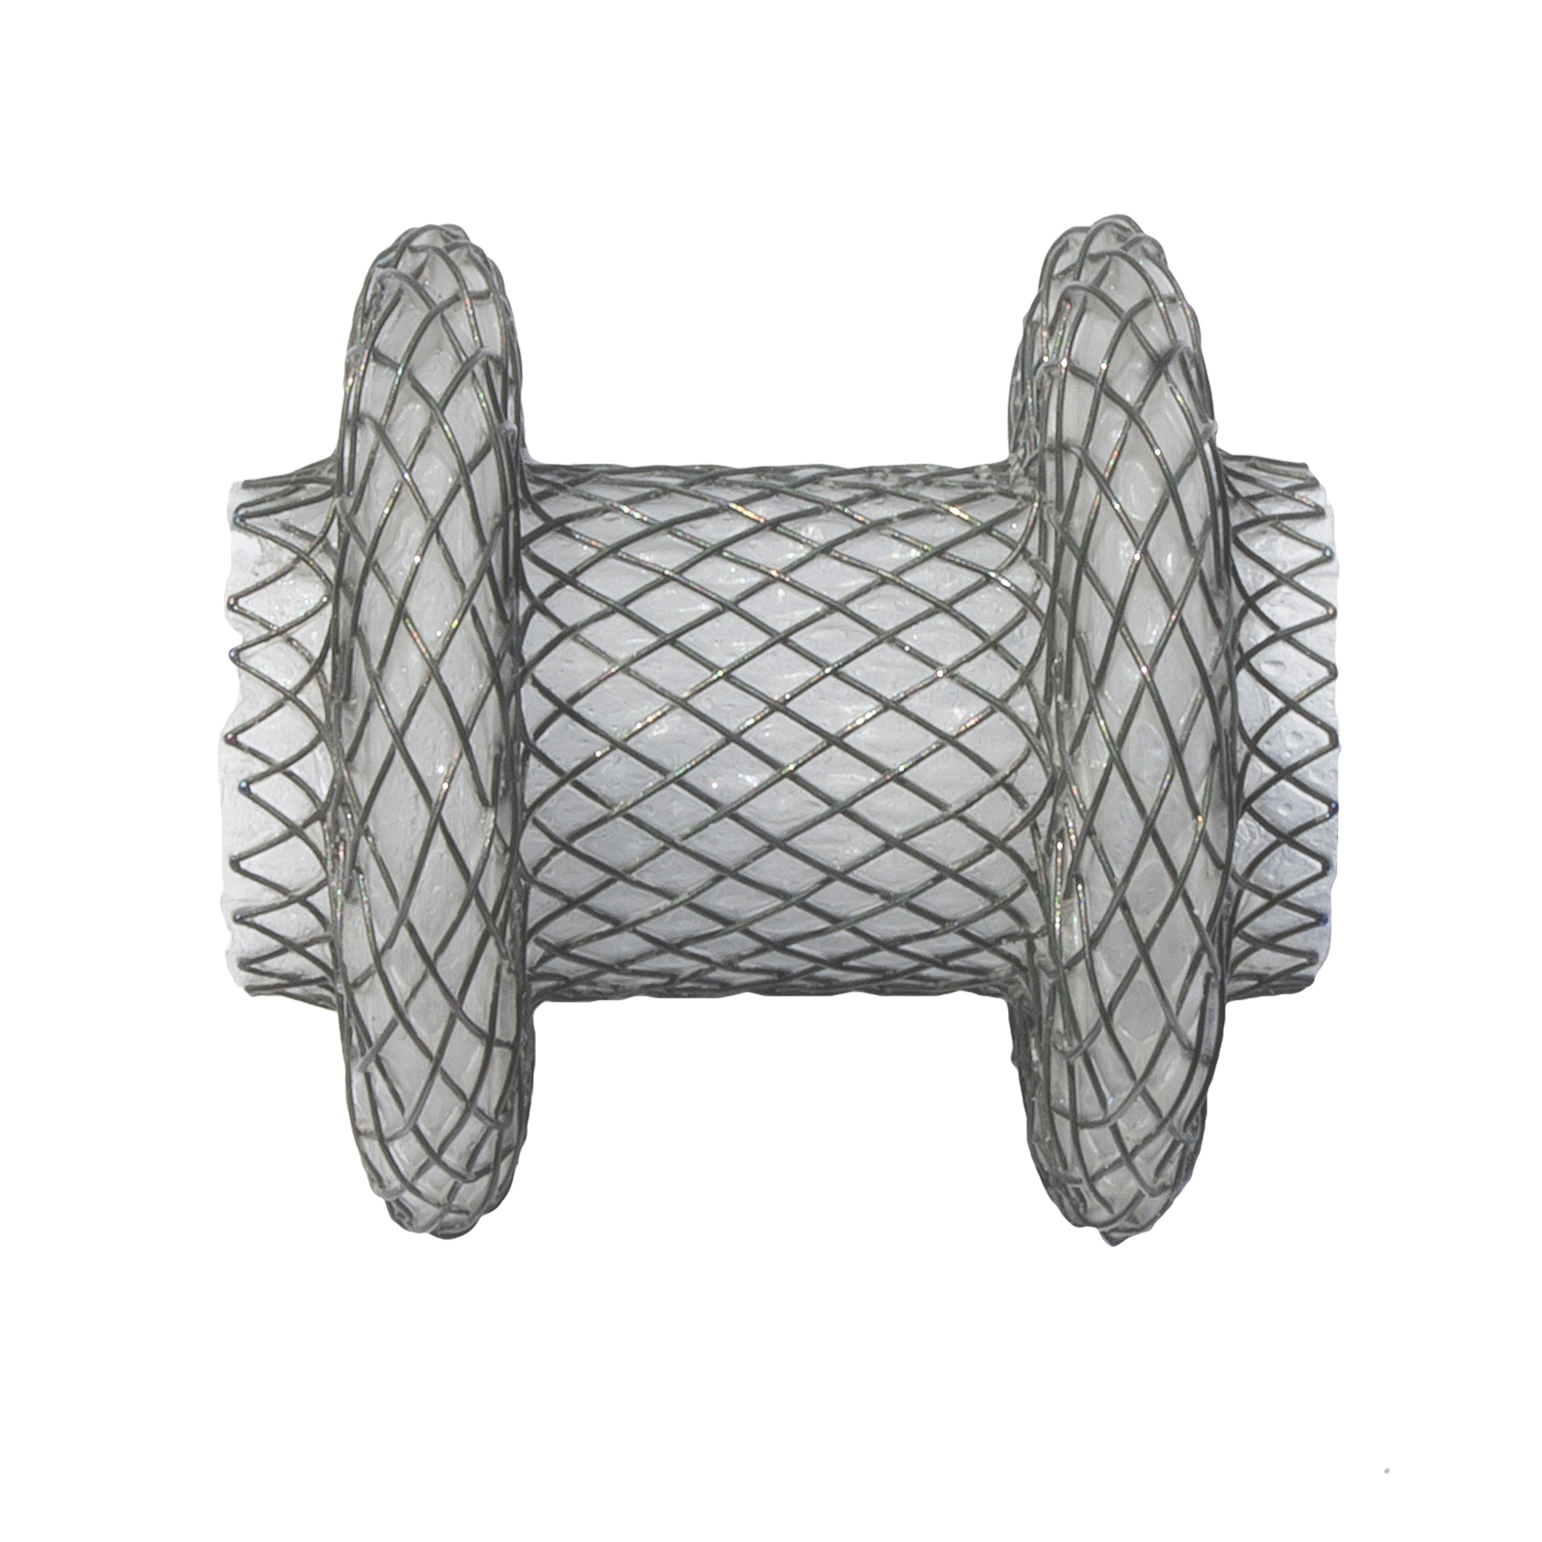

Figure 2 – AXIOS Stent delivery system

