Figure 2: Axial MRI T1(A) and T2 (B). Cystic dilatations of bile ducts distributed diffusely in the liver parenchyma.

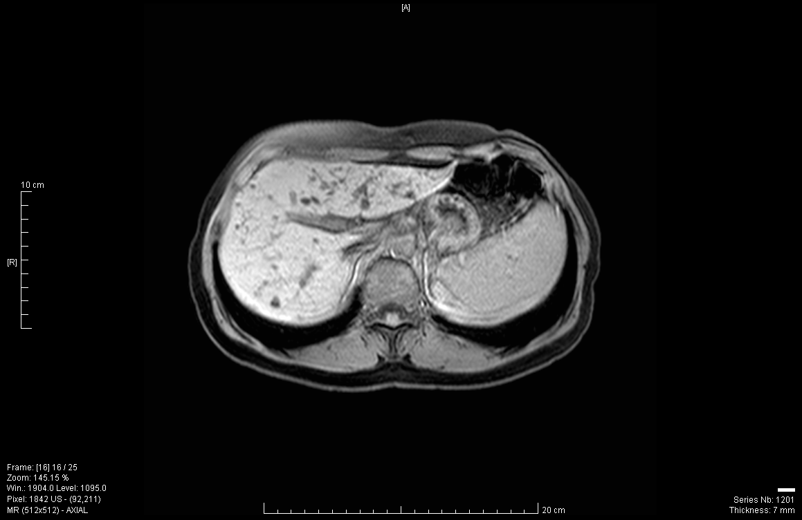
A
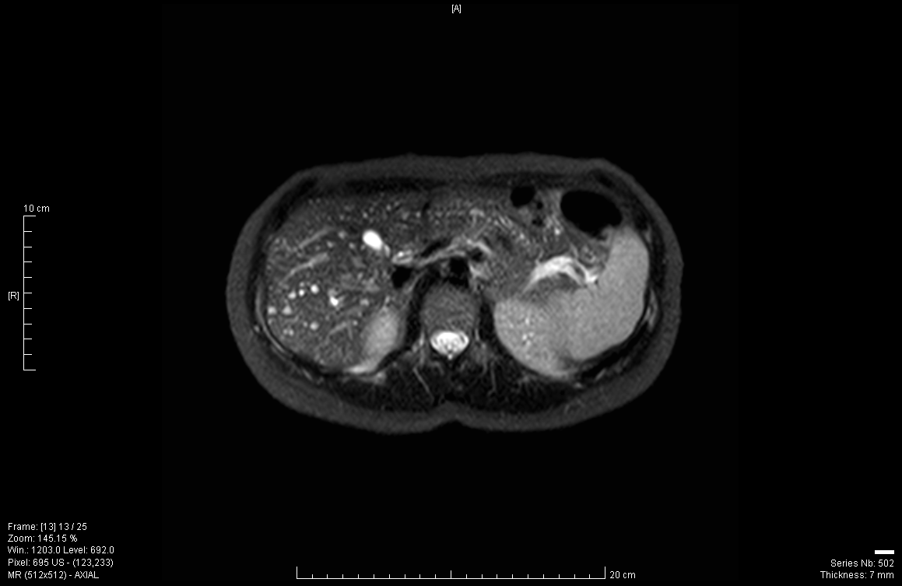
B

